Functional Specification

Year: 2022 Semester: Spring Team: 8 Project: Gimbal Vehicle

Creation Date: January 19, 2022 Last Modified: January 19, 2022

Author: Zeren Li, Bohang Ni, Deyuan Sun, Haiwen Zhang

Email: [ni67@purdue.edu](mailto:ni67@purdue.edu) [li3103@purdue.edu](mailto:li3103@purdue.edu) [sun829@purdue.edu](mailto:sun829@purdue.edu) [zhan3237@purdue.edu](mailto:zhan3237@purdue.edu)

Assignment Evaluation:

| **Item** | **Score (0-5)** | **Weight** | **Points** | **Notes** |
| --- | --- | --- | --- | --- |
| **Assignment-Specific Items** | | | | |
| **Functional Description** |  | x3 |  |  |
| **Theory of Operation** |  | x3 |  |  |
| **Expected Usage Case** |  | x3 |  |  |
| **Design Constraints** |  | x3 |  |  |
| **Writing-Specific Items** | | | | |
| **Spelling and Grammar** |  | x2 |  |  |
| **Formatting and Citations** |  | x1 |  |  |
| **Figures and Graphs** |  | x2 |  |  |
| **Technical Writing Style** |  | x3 |  |  |
| **Total Score** |  | | |  |

5: Excellent 4: Good 3: Acceptable 2: Poor 1: Very Poor 0: Not attempted

General Comments:

*Relevant overall comments about the paper will be included here*

1.0 Functional Description

We will design a Gimbal Vehicle infrastructure. This vehicle is capable of omnidirectional moving. This vehicle’s gimbal is capable of maintaining horizontal and vertical stability regardless of the status of the chassis. We can also manually set the direction that the gimbal is facing, or let it face a default direction. Also, users can monitor IMU parameters of the vehicle in real-time from the LCD screen on the controller. Other users are capable of adding more functionality to our infrastructure.

Here is a 3D model preview we made(Only for preview, not complete yet):

<https://sketchfab.com/3d-models/mecanum-gimbal-car-model-27485e6865d845f8aeb01d742ae7f013>

2.0 Theory of Operation

The purpose of Gimbal Vehicle is to convenience users to perform various filming tasks in indoor and outdoor environments. Also, we will allow users to choose their favorite video or photo capture device.

There are two parts to the operations, one is the vehicle part, and one is the controller part. The vehicle part consists of the chassis and the gimbal station. The controller comprises two joysticks, one single pull double throw switch (SPDT switch), and a push-button. The push-button is to reset the gimbal station to the default location. The SPDT switch is designed to switch between the vehicle’s driving mode and gimbal control mode.

In the driving mode, the operator will utilize the joystick for the movements of the vehicle between locations of interest, and the rotation of the vehicle. During vehicle movement, the gimbal station will track the desired direction and stabilize the optical device that is mounted to the gimbal station.

In the gimbal control mode, the operator will have control of the gimbal station and set the tracking direction of the optical device. The operator’s driving control is limited in this mode to forward and backward movement, and the rotation function of the vehicle will be disabled. The operator could manipulate the vehicle and the gimbal station through the joysticks. The controller communicates to the vehicle through a wireless transceiver module.

The vehicle chassis consists of four Mecanum wheels powered by four independent motors which are capable of four-wheel driving operations. Each motor was installed with two hall effect sensors for real-time velocity feedback for the velocity closed-loop controller through velocity PID control. This design ensures the vehicle could move smoothly through rough terrain. The gimbal station is powered by two servos and one inertial measurement unit (IMU). The microcontroller (MCU) operates by taking real-time IMU feedback and positioning PID control to stabilize the gimbal station. An LCD screen will display real-time vehicle information such as vehicle speed, yaw angles, pitch angles, roll angles, and vehicle battery life.

**Hall effect**: Our motor has two hall effect sensor that is able to time the speed of wheels and shafts

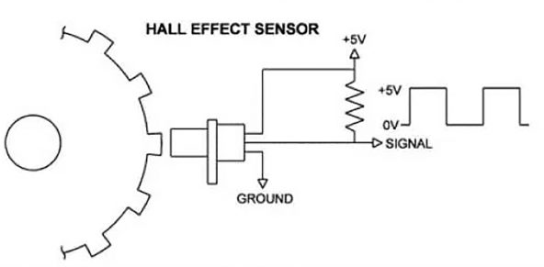

By utilizing two Hall effect sensors, we can get two same pulse waves that one is a 90-degree shift version compared to the other. Let’s call two pulse waves, wave A and wave B. To determine the direction of motion, at the rising edge of wave A, if wave B is at a low state, it means the motor rotates counterclockwise. If wave B is at a high state, it means the motor rotates clockwise. To determine the speed of the motor, we capture the total pulse in 1 second, and times 60 to get the speed in the unit of round per minute.

**Proportional–integral–derivative controller** (PID): The design of Algorithms for our Gimbal will rely on PID. It provides a control loop mechanism based on the feedback from Inertial measurement unit (IMU) parameters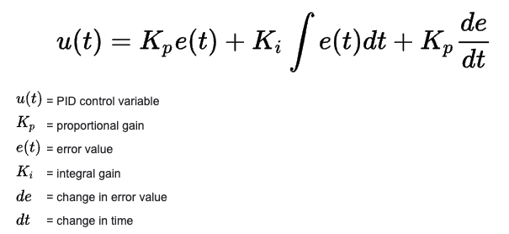

Kalman Filter: The software will read acceleration data from MPU6050 (IMU) which is mounted on the chassis of the vehicle. The data will be used along with Kalman Filter to calculate the pitch and roll angle of the device. The angle data will be later used for PID control of the gimbal.

For more information, Please check Appendix A on the last page.

3.0 Expected Usage Case

The product is expected to operate both indoors and outdoors. The product will be portable in nature. The product is expected to be operated by one user at a time. A typical user of our product would be a person who is passionate about film. One example usage case would be a social media content creator using our product to shoot nature scenery footage for a Vlog.

4.0 Design Constraints

In our design, we have our implementation to be suitable for both indoor use and outdoor use, it will conquer most of the terrains, including but not limited to flat ground, sandy beach, grassland, etc. However, due to the gimbal feature we are about to include, we have not incorporated any climbing system, such as stair-climbing or obstacle climbing, and our design has not incorporated a self-recovery system of rollover.

4.1 Computational Constraints

The primary computational functions of Gimbal Vehicle are to read and send angular velocity on the Z-axis from the IMU, send the data package to transceiver module via SPI, Display information on the OLED Screen, Perform increment PID Control algorithm, and position PID Control algorithm.

In order to get an accurate Yaw angle by converting angular velocity to angle, a large sample rate will be required. Also, we need to utilize Accelerometer in the IMU, angular velocity of Yaw, and Kalman filter to calculate the angle for Row and Pitch of Vehicle.

we need to utilize Accelerometer in the IMU, angular velocity of Yaw, and Kalman filter to calculate the angle for Row and Pitch of Vehicle. Hence, a microcontroller with a clock larger than 30MHz will be favored.

4.2 Electronics Constraints

The main electrical components of the Gimbal Vehicle will include two microprocessors, four hall sensor encoders, two h-bridge motor drivers, accelerometers, an LCD screen, two joysticks a pair of wireless transceiver modules (nrf24l01).

| Components | Interface |
| --- | --- |
| Wireless transceiver module(I/O device) | SPI |
| hall sensor encoder(sensor and I/O device) | Timer |
| LCD screen(I/O device) | I2C |
| accelerometer(sensor) | I2C |
| joystick(I/O device) | ADC |
| h-bridge motor drivers(I/O device) | GPIO and PWM |

4.3 Thermal/Power Constraints

For the Vehicle part, the servo’s stall current is 2.5A, and the running current is 500mA to 900mA both under-voltage of 5V, stall torque is 9.4 kgf·cm at 5V, and operating speed is at 0.17 s/60º at 5V. The higher voltage supply will provide higher torque. The motors are working from 12V to 9V. The stall current is 2.3A, and the running current is less than 1A.

Due to our power constraint, we might want to supply servos and motors power through a rechargeable battery.

For the Controller part, we will power it through a 9V alkaline battery, with no other power Constraints for controller parts.

4.4 Mechanical Constraints

The vehicle is able to drive in indoor and outdoor flat surfaces environments. It is also able to drive on the grass. The product is not waterproof. The vehicle should be able to withstand the moderate shock from driving. Due to the fact that Mecanum wheels are more likely to slip because of the diagonal rollers, it is recommended to drive the vehicle at a lower speed when the road is slippery.

4.5 Economic Constraints

Our total cost will be around 650 USD. We consider this price to be higher than an actual product going into the market using the same component under the wholesale price. Besides, the price of lots of components drastically increased last year due to the shortness of the world’s electronic components production line. If this can be manufactured in a regular time with wholesale price components, we expect the price to drop to around 300 USD.

4.6 Other Constraints

5.0 Sources Cited:

[1] “Understanding PID control and loop tuning fundamentals,” *Control Engineering*, 26-Jul-2016.[Online]<https://www.controleng.com/articles/understanding-pid-control-and-loop-tuning-fundamentals/#:~:text=The%20PID%20formula%20weights%20the,D%20is%20the%20derivative%20time.>

[2] “Holonomic Drivetrains.” *Game Manual* ,[Online]<https://gm0.org/en/latest/docs/common-mechanisms/drivetrains/holonomic.html.>

[3] “Hall Effect or Reluctor?” *Haltech*, 18 Feb. 2020, [Online]<https://www.haltech.com/hall-effect-or-reluctor/.>

Appendix 1: Functional Block Diagram

